Chapter 8: Comparing GUIs
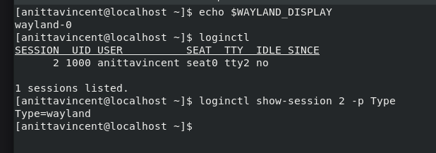
echo $WAYLAND_DISPLAY: Prints the current Wayland display name, confirming that your session is running on Wayland.
loginctl: Lists all active user login sessions on the system.
loginctl show-session 2 -p Type: Shows only the session type (e.g., Wayland or X11) for session ID 2.

Chapter 9: Adjusting Localization

Exercise 9.a: View the localization settings for your Linux system
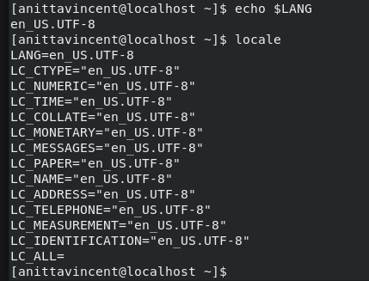
echo $LANG prints the system’s current default language/locale setting. The command locale displays all locale-related environment variables currently active on the system.

Exercise 9.b: Display the locales installed on your Linux system
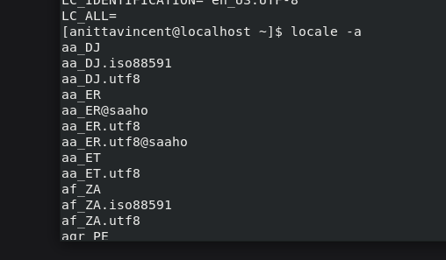
Lists all locales installed and available on the system.

Exercise 9.c: Working with timezones
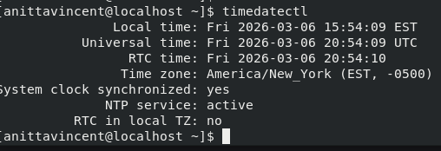
Shows the system’s current date, time, timezone, NTP status, and RTC (hardware clock) configuration.

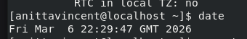
Displays the current system date, time, and timezone according to the system clock.

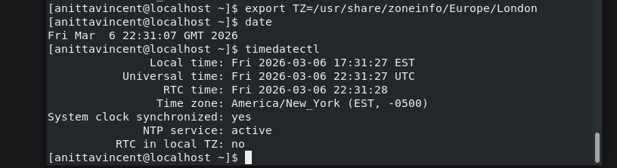

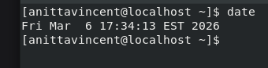
Temporarily sets the timezone for the current shell session only (does not change system timezone). The date command Prints the current date/time using the timezone defined by the TZ variable.
The command timedatetcl Shows the system’s actual timezone configuration (unchanged because export TZ does not modify system settings).
Shows the system’s actual timezone configuration (unchanged because export TZ does not modify system settings). The date command prints the current system date, time, and timezone using the system’s configured clock settings.

Chapter 10: Administering Users and Groups
Ancillary Exercise 10.a: Managing Users and Groups

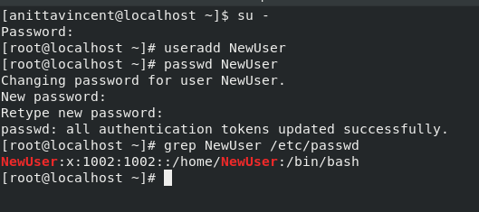
su - → switches to the root account
useradd NewUser → creates a new user
passwd NewUser → sets password for the new user
grep NewUser /etc/passwd → displays the user’s account entry

Record the NewUser account’s data information for each field:
1) username: NewUser
2) password: x
3) UID: 1002
4) GID: 1002
5) Full Name: none/blank
6) Home Directory: /home/NewUser
7) Default Shell: /bin/bash

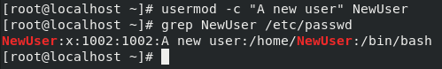
Modify the NewUser account’s Comment field and grep NewUser /etc/passwd lets see that the Comment field for the NewUser account has been modified.

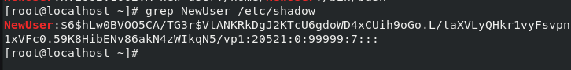
- Username: NewUser
2) Password: (Don’t write this one down)
3) Last modified: 20521
4) Min days: 0
5) Max days: 99999
6) Days warn: 7
7) Disabled days: blank
8) Expire:blank
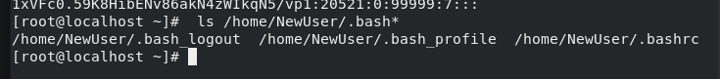
ls home/NewUser/.bash* lets see any hidden bash environment files that were created when the account was created.
The /etc/skel directory, also called the “skeleton directory” contains files to be copied to newly created account’s home directories.
- What directory is set to store the user mail files?:
(Hint: Find MAIL_DIR) /var/spool/mail
b) What is the maximum number of days a password can be used set to?:
(Hint: Find PASS_MAX_DAYS) 99999
c) What is the setting for the minimum number of days allowed between
password changes?:
(Hint: Find PASS_MIN_DAYS) 0
d) What is the minimum password length allowed?
(Hint: Find PASS_MIN_LEN) 5
e) A user is warned how many days before a password expires?: (Hint: Find
PASS_WARN_AGE)7

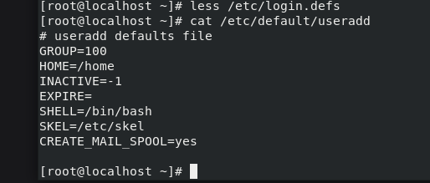
GROUP=100
HOME=/home
INACTIVE=-1
EXPIRE=______________
SHELL=/bin/bash
SKEL=/etc/skel
CREATE_MAIL_SPOOL= yes
The /etc/default/useradd file is another of the configuration files used for setting various default account values, when creating user accounts
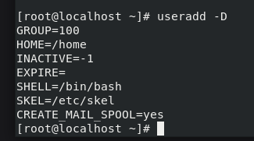
The useradd -D command lists out the /etc/default/useradd file’s contents
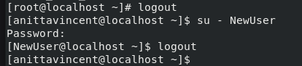
At the prompt type usermod -s /bin/false NewUser and press Enter. This command allows you to modify the account’s default shell. In this case, you changed it to /bin/false.

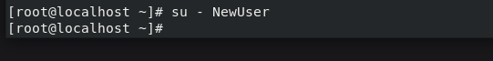
Trying to log in as NewUser using the pass1_1word as the password, but not able to login to the NewUser account.
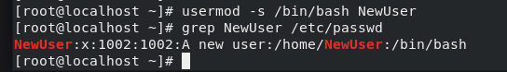
usermod -s /bin/bash NewUser: Changes the login shell for user NewUser to /bin/bash. This edits the last field of /etc/passwd.
grep NewUser /etc/passwd shows the full account entry for NewUser from the /etc/passwd file.

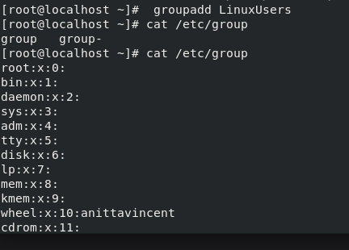
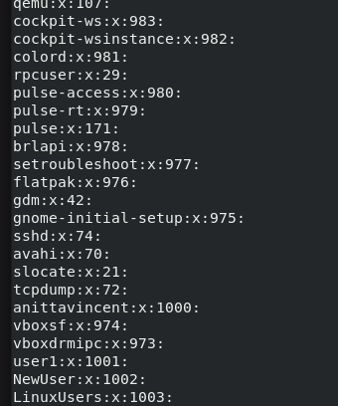
groupadd LinuxUsers This created a new group LinuxUsers and then check the contents of /etc/group using cat command.

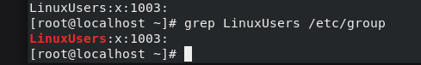
1) Group_Name: LinuxUsers
2) Password: x
3) Group_Admins: none
4) Group_Members: none
Group id is 1003
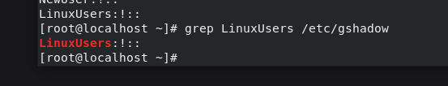
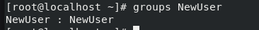
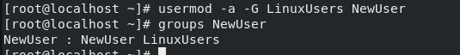
grep LinuxUsers /etc/gshadow: Shows the secure shadow-group entry for the group LinuxUsers from /etc/gshadow.
groups NewUser : Displays all groups that the user NewUser currently belongs to.
usermod -a -G LinuxUsers NewUser: Adds NewUser to the supplementary group LinuxUsers without removing existing group memberships.
groups NewUser : Verifies that NewUser is now a member of both their primary group and LinuxUsers.
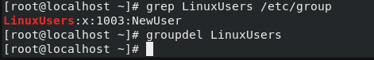
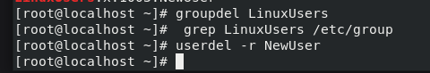

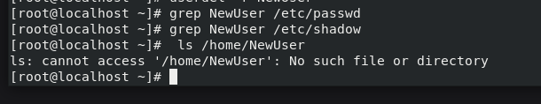
grep LinuxUsers /etc/group : Displays the LinuxUsers group entry from /etc/group, including its GID and members.
groupdel LinuxUsers : Deletes the group LinuxUsers from the system.
grep LinuxUsers /etc/group: Checks if the deleted group still exists in /etc/group.
userdel -r NewUser: Deletes the NewUser account and removes its home directory.
grep NewUser /etc/passwd: Checks whether the user entry for NewUser still exists in /etc/passwd.

grep NewUser /etc/shadow: Checks whether the secure password entry for NewUser still exists in /etc/shadow.
ls /home/NewUser: Tries to list the home directory of NewUser to confirm it has been removed.

Exercise 10.b: Using Account Tools to Discover Who is Online
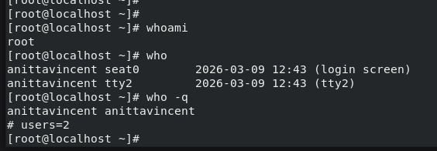

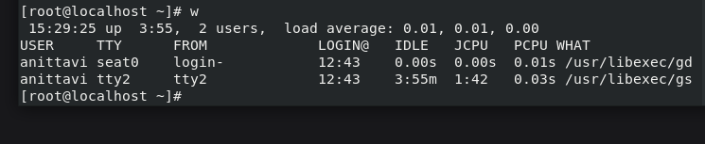
whoami: Prints the username of the account currently running this shell session.
who: Shows all users currently logged in and their login terminals, along with login times.
who -q: Lists logged-in usernames and shows how many total users are logged in.
w: Displays who is logged in and what each logged-in user is currently doing, including idle time and CPU usage.
------------------------------------------------------------------------------------------------------------------
Chapter 11: Handling Storage
Ancillary Exercise 11.a: Determining hard drives on the system
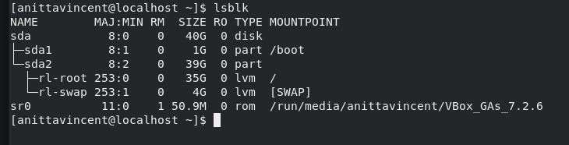
lsblk shows the drive names in the first column, and the drive type in the sixth column. The mountpoint column shows where each partition or logical volumn (if using LVM) is mounted in the virtual directory hierarchy, of if it is used as a swap space.
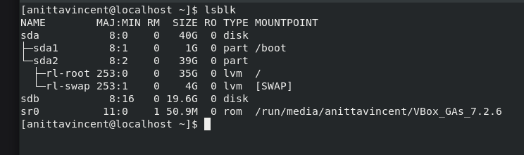
lsblk output after adding harddisk sdb
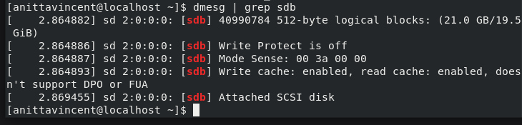
Filters kernel boot messages to show only entries related to the storage device sdb.

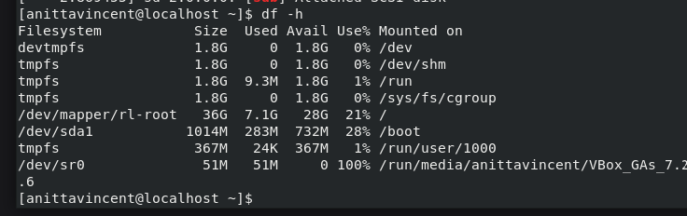
The output lists filesystems, their sizes, used and available space, and mount points.

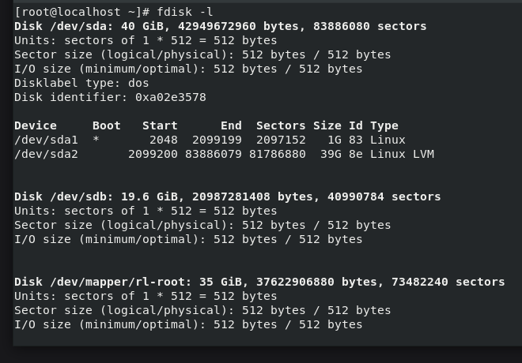
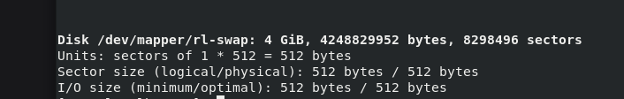
fdisk -l lists all disks and their partitions, showing device names, sizes, types, and partition tables.

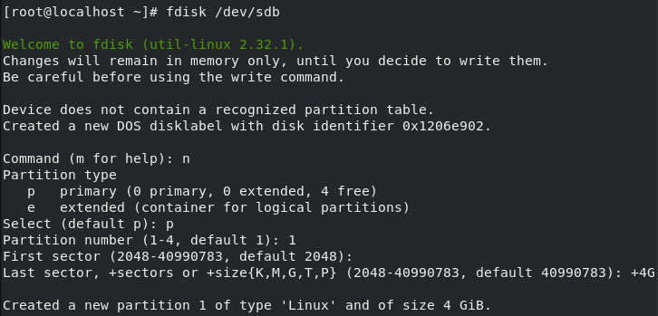
Created a new partition 1 of type 'Linux' and of size 4 GiB.

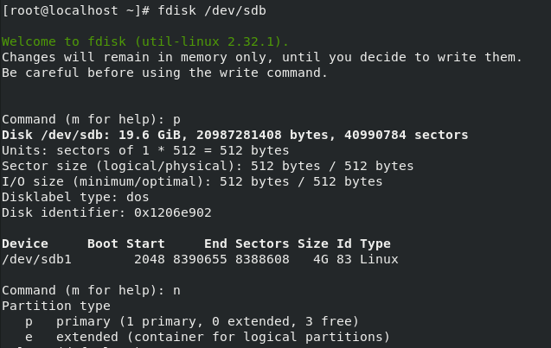

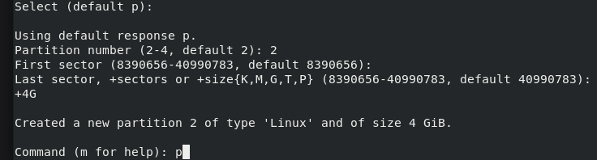
Created sdb2 partition of size 4 GB
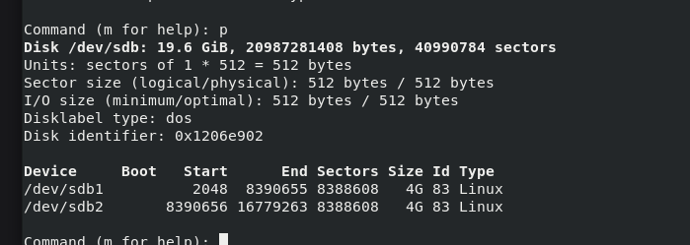
Inside the interactive fdisk session, p prints the current partition table of /dev/sdb.
Now sdb2 partition is also created.

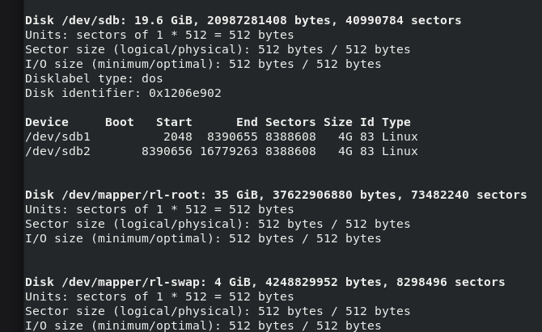
Prints the current partition tables of all recognized disks, showing partition numbers, sizes, and types.

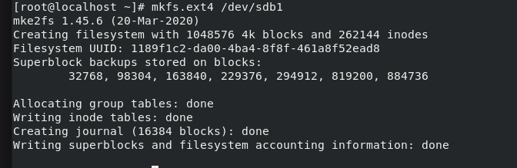
Creates an ext4 filesystem on the partition /dev/sdb1, erasing existing data and preparing it for use.

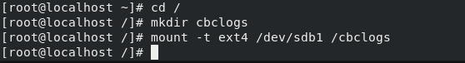

Changes the current working directory to the root (/) directory, Creates a new directory named cbclogs inside the root directory and mounts the ext4 filesystem on /dev/sdb1 to the /cbclogs directory, making the partition accessible.

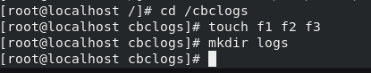
Changes the current directory to /cbclogs, the mounted filesystem location., Creates three empty files named f1, f2, and f3 inside the /cbclogs directory and creates a new subdirectory named logs inside /cbclogs.

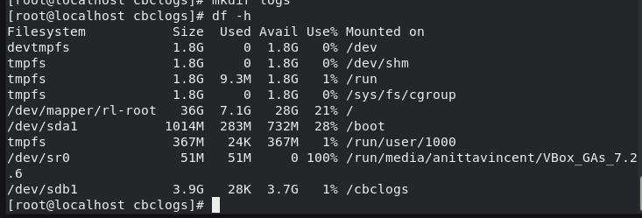
The output lists all mounted filesystems and their disk usage. This confirms that /dev/sdb1 is mounted on /cbclogs and is using only 1% of space.

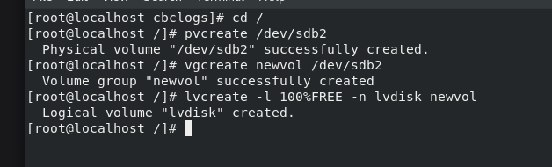
Initializes /dev/sdb2 as an LVM physical volume so it can be used for LVM storage., then, Created a new LVM volume group named newvol using the physical volume /dev/sdb2. Next, Created a logical volume named lvdisk that uses 100% of the free space in the newvol volume group.

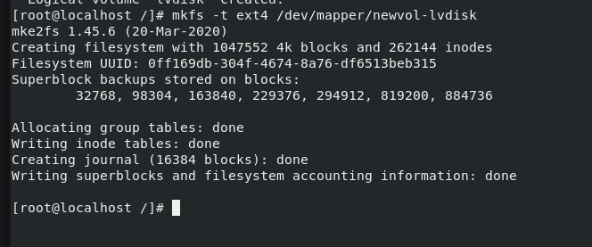
Creates an ext4 filesystem on the logical volume /dev/mapper/newvol-lvdisk, making it ready for mounting and storage use.

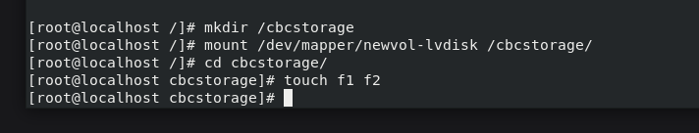
Creates a new directory /cbcstorage to serve as the mount point for the logical volume, Mounts the logical volume newvol-lvdisk at the /cbcstorage directory so it can be accessed like normal storage, Changes the current working directory to /cbcstorage, the mounted filesystem and Creates two empty files named f1 and f2 inside the mounted /cbcstorage directory.

View entries of /etc/fstab using vim /etc/fstab
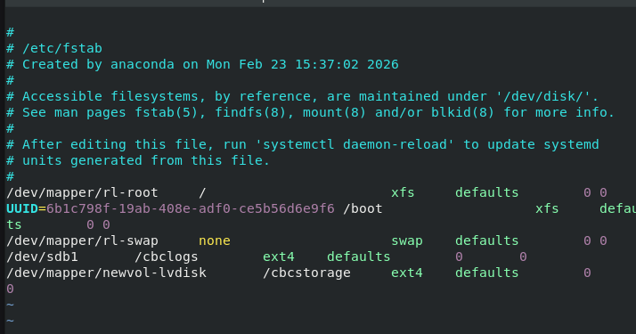
Edit the fstab file and add entries (listed in last two lines)
Mounts all filesystems listed in /etc/fstab that are not already mounted. Reloads systemd configuration to apply any changes made to system mount units or services.
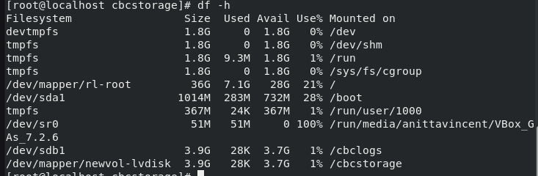
Displays the disk usage and available space for all mounted filesystems in human-readable format (GB/MB).

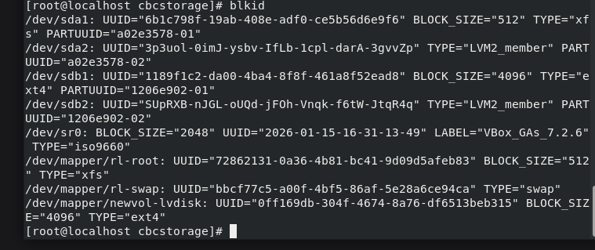
Displays UUIDs, filesystem types, and metadata for all detected block devices.

After reboot:
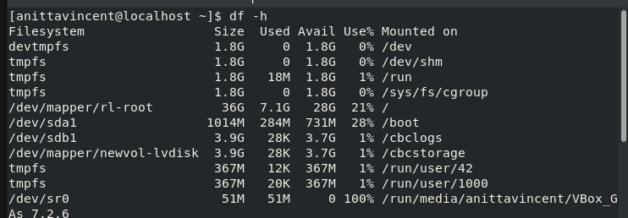
Shows disk usage and available space for all mounted filesystems in human-readable format.

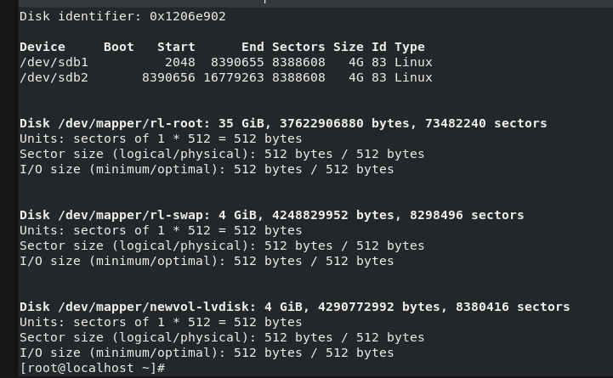
Output of fdisk -l which lists all disks and partitions, showing their sizes, sectors, and partition types.
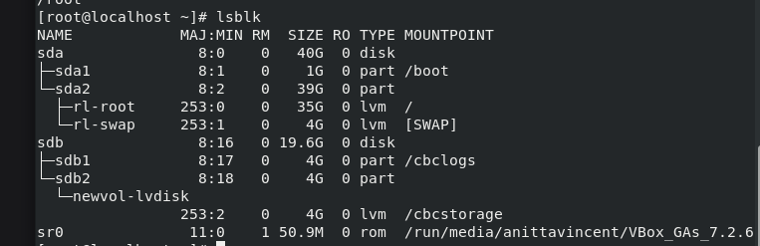
Displays block devices in a tree view with their sizes, types, and mount points.
Chapter 12: Protecting Files
Ancillary Exercise 12.a: Using tar for Backups
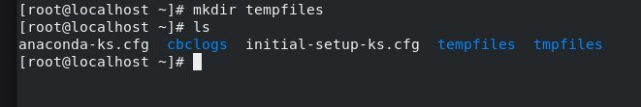
Make a directory called tempfiles in /root and list it.
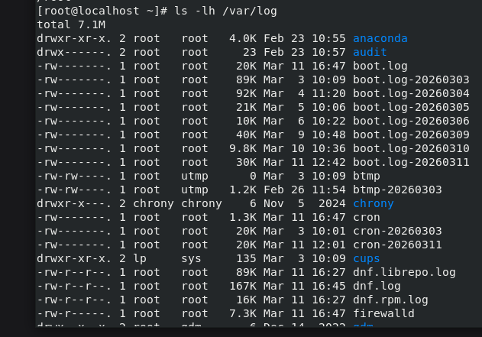
Lists all files and directories inside /var/log with human-readable sizes, permissions, owners, timestamps, and names.

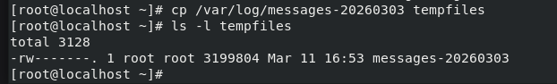
Copies the file /var/log/messages-20260303 into the directory tempfiles.
Shows detailed file information (permissions, owner, size, timestamp) for everything inside the tempfiles directory.

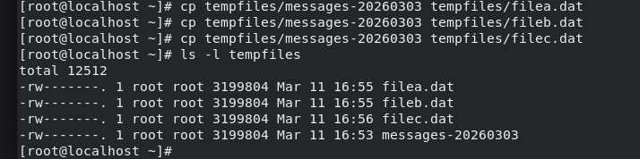
Makes a copy of messages-20260303 and saves it as filea.dat, fileb.dat,filec.dat in the same directory. Lists the files in tempfiles folder.

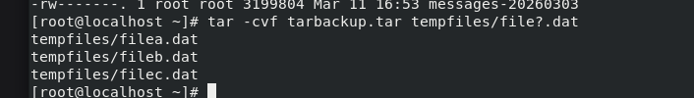
tar → the archive tool
-c → create a new tar file
-v → verbose mode (shows which files are added)
-f tarbackup.tar → name of the tar file to create
tempfiles/file?.dat → a wildcard pattern

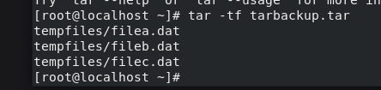
list the contents of the tar archive without extracting it.

compresses the file using gzip , replaces the original file with a compressed version and produces a new file with the extension .tar.gz (or .tgz)

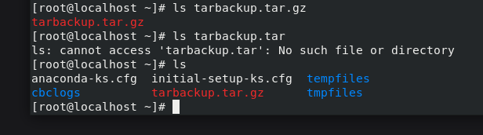
ls tarbackup.tar.gz gives output tarbackup.tar.gz. This means the gzip compression succeeded. In the next ls command, Because gzip replaces the original .tar file with the compressed .tar.gz file , the original tarbackup.tar no longer exists.

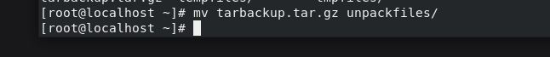
This command moves the compressed archive (tarbackup.tar.gz) into the directory named unpackfiles/.

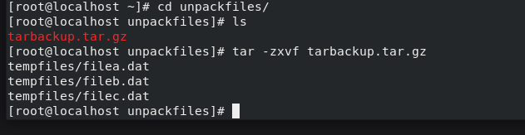
Extract a .tar.gz archive

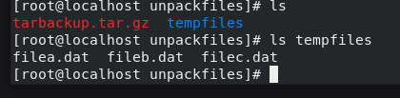
List the files in unpackfiles folder and tempfiles folder
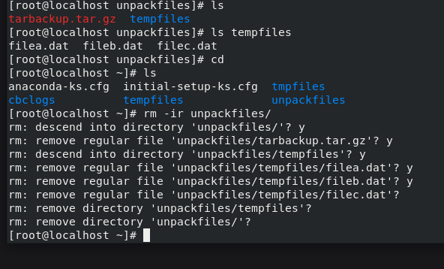
Remove the directory unpack files.

Exercise 12.b: Using cpio for Backups

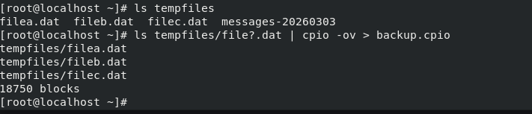
Archive all files matching file?.dat using cpio in “copy out” mode and save the archive as backup.cpio.

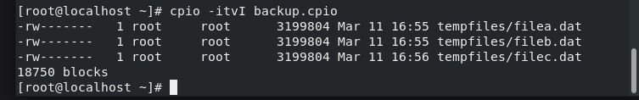
Display the contents of backup.cpio in a long, detailed, human-readable format without extracting anything.

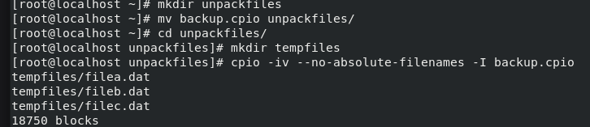
A directory named unpackfiles is created. The file backup.cpio is moved into that directory. change into the directory and create a tempfiles directory inside it
Extract backup.cpio into the current directory, ignoring any absolute paths so files unpack safely into the working folder.

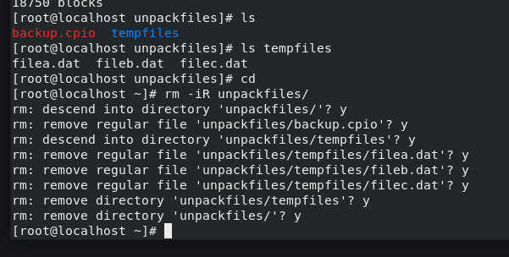
Recursively remove the unpackfiles/ directory and everything inside it, prompting for confirmation before each deletion step.

------------------------------------------------------------------------------------------------------------------
Chapter 13: Governing Software
Ancillary Exercise 13.a: Bundling files using tar
Create files file01, file02, file03
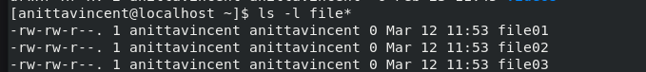
List the files starting with ‘file’
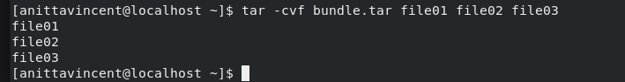
Create a tar archive named bundle.tar and add file01, file02, and file03 to it while showing each file as it is added.

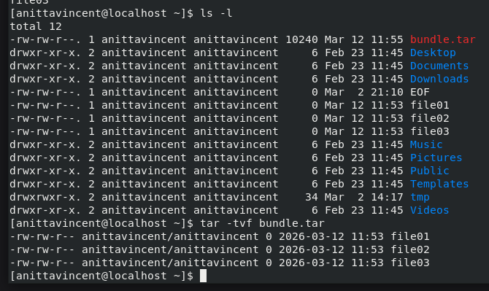
List the files in the directory using ls command and List (without extracting) the contents of the tar archive bundle.tar with detailed file info using tar -tvf command.

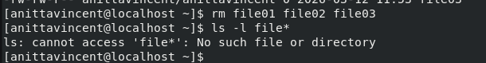
Remove file01,file02,file03 and verify if they are removed.
Exercise 13.c: Use Red Hat package management tools
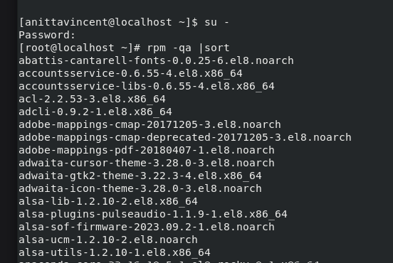
Switch as root user, and list all installed RPM packages (rpm -qa) and sort them alphabetically (sort).

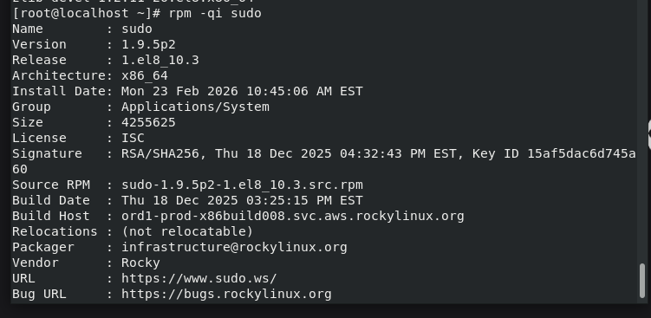
Show detailed information about the installed sudo package, including version, install date, size, license, source RPM, build host, vendor, and URLs. (-q Query a package (ask RPM for information about it). -I Show detailed package information (full info block).

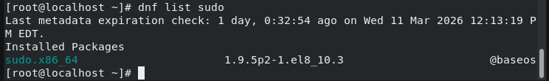
List the installed version and repository information for the package named sudo.

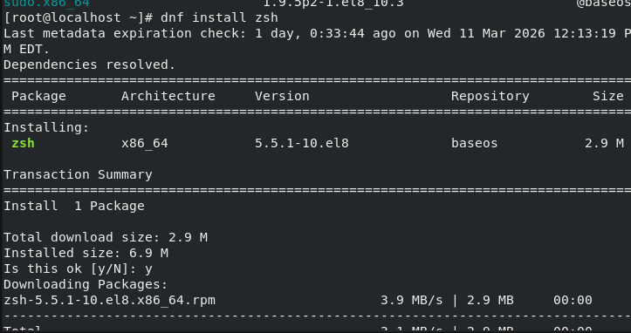
Install the zsh package onto the system using DNF, automatically resolving and downloading required dependencies.

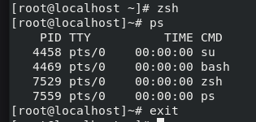
zsh starts a new interactive zsh shell session. ps shows all running processes attached to the current terminal (TTY).

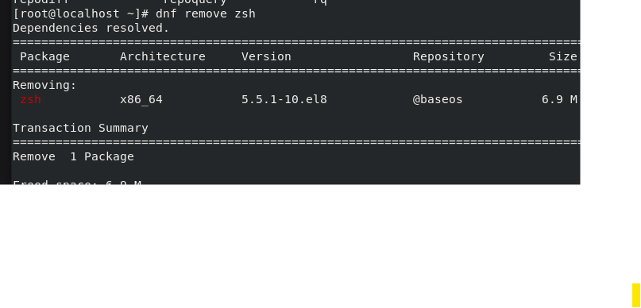
dnf remove zsh remove the zsh package from the system using DNF and free the associated disk space.

Chapter 14: Tending Kernel Modules
14.a: Exploring Kernel Modules

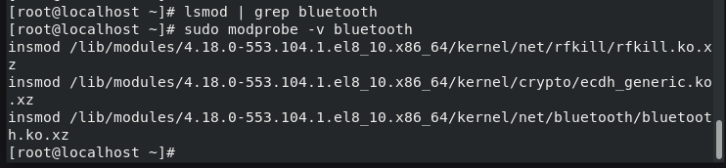
List loaded kernel modules and filter for bluetooth, Load the bluetooth kernel module and show verbose details about how it is inserted.

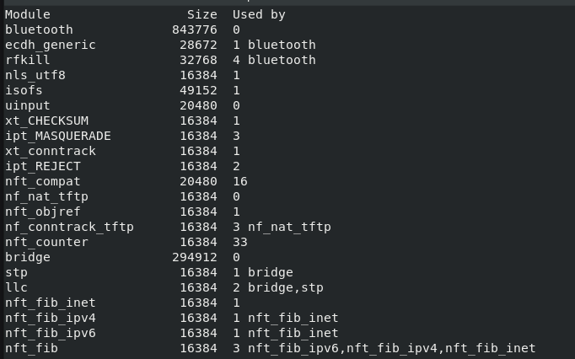
Load the Bluetooth kernel module, by typing sudo modprobe -v Bluetooth. The -v option
allows you to see the module load as well as any needed dependencies
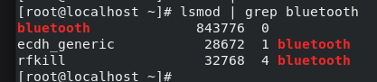
List loaded kernel modules and filter for bluetooth

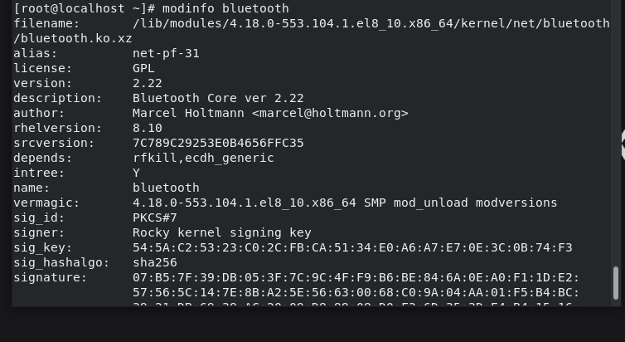
Displays metadata about the bluetooth kernel module, including filename, version, dependencies, signature, and kernel version it was built for.

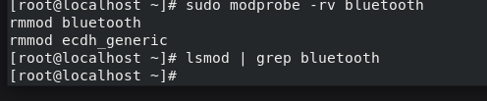
Unload (-r) the bluetooth kernel module verbosely (-v), and automatically remove dependent modules as well. List all loaded kernel modules (lsmod) and filter the output for the word “bluetooth”.

